*OUR PRODUCTS PAGE*

\*Dropdown menu for “Our Products”

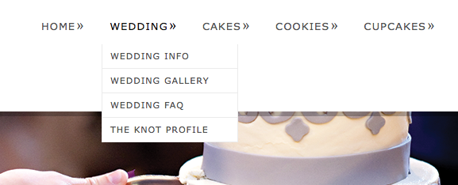

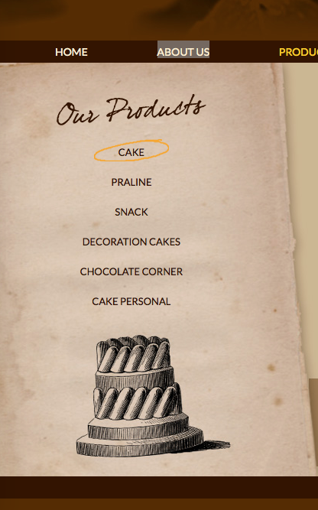Our Products:

1. Cheese
2. Chocolate
3. Cookies and Cream
4. Fruits
5. Green Tea
6. Red Velvet

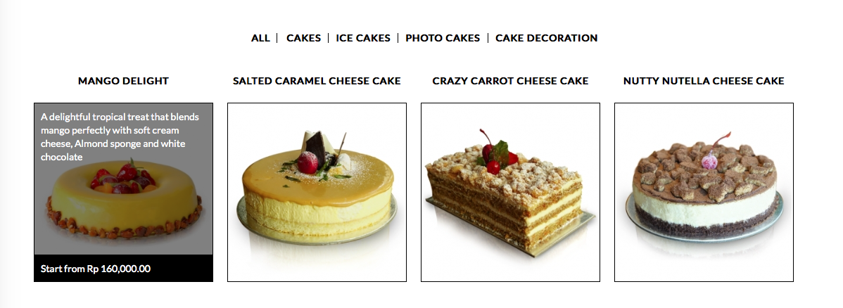

Pas picturenya di klik, redirect ke detail productnya gitu

Quantity:

[Product Name]

[Price]

\* Note:

Nama product: [Nama File (gapake angka)]

Price product: [Angka di belakang nama file]

Quantity: 1 sampe 4 (pake dropdown menu)